Lab 6 Part 2 – Preetham Thelluri

Part A:

1. 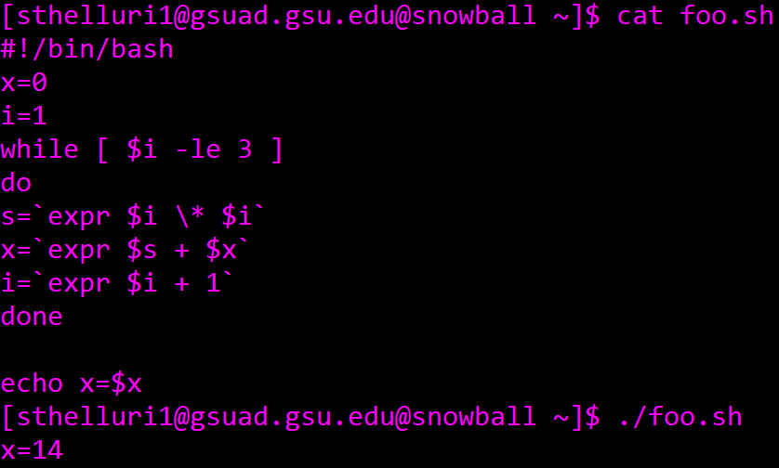
2. This code prints the sum of all squares from 1 to 3.

Part B:



Part C:



Part D:

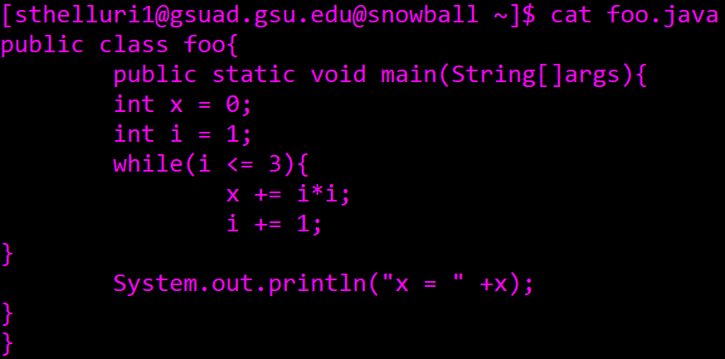

public class foo{

public static void main(String[]args){

int x = 0;

int i = 1;

while(i <= 3){

x += i\*i;

i += 1;

}

System.out.println("x = " +x);

}

}

Part E:

1. 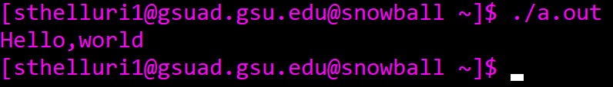
2. A new file called “hello” is created.
3. 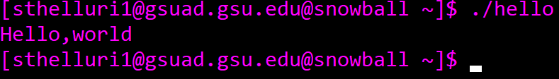
4. 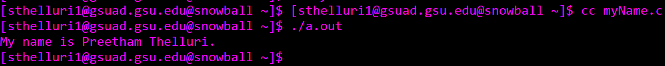

#include <stdio.h>

int main(void){

printf("My name is Preetham Thelluri.\n");

return 0;

}